Project: Healthcare - Persistency of a drug

**Week 10: Deliverables**

**Name:** Krishna Ratna Deepika Haripuram **Email:** [haripuramdeepika@gmail.com](mailto:haripuramdeepika@gmail.com) **Country:** Canada

**Batch Code:** LISUM26 **Specialization:** Data Science **Submission Date:** Dec 4th, 2023 **Submitted to:** Data Glacier

(Individual Project)

# Table of Contents

1. Problem Description
2. Github Repo link
3. EDA performed on the data
4. Final Recommendation

**1. Problem Description:**

This project focuses on analyzing the persistency of drug usage as prescribed by physicians in a healthcare dataset. The main goal is to identify factors influencing drug persistency and build a predictive model to classify patients based on their medication adherence (Persistency_Flag). This analysis is critical for pharmaceutical companies to enhance patient care and optimize treatment strategies.

2.Github Repo Link

<https://github.com/krishnaharipuram/Data-Glacier/tree/main/Week%209>

**3. EDA performed on the data**

**a. Distribution of Persistency Flag**

The pie chart depicts the overall distribution of the persistency flag among patients. A significant majority show persistence, but there remains a considerable portion that is non-persistent, highlighting the need for targeted interventions.

**b. Normalized Side-by-Side Bar Chart: Gender vs Persistency**

This normalized bar chart compares drug persistency rates between genders. While there are slight differences, both genders show substantial non-persistent populations, indicating a need for gender-specific adherence strategies.

**c. Ethnicity and Its Impact on Drug Persistency**

The bar chart explores how ethnicity affects drug persistency, with notable differences between ethnic groups.

Understanding cultural and social factors could be key to improving patient-specific treatment plans.

**d. Distribution of Patients by Race and Persistency Flag**

This stacked bar chart provides insight into drug persistency rates across different races. The proportion of persistency within each racial group highlights potential disparities that could be addressed to improve medication adherence.

**e. Age Distribution Among Different Persistence Groups**

The bar chart compares the age distribution between persistent and non-persistent patients. It reveals that persistence does not significantly differ across age groups, suggesting that other factors may play more critical roles in persistency.

**f. Specialties of Healthcare Providers (Word Cloud)**

The word cloud visually represents the various healthcare provider specialties, with the size of each term indicating its frequency. General practice, surgery, and oncology are prominently featured, which could be influential in-patient drug persistency.

**g. NTM Physician Specialty Distribution**

The bar chart showcases the distribution of NTM physician specialties. General practitioners are the most common, followed by rheumatologists and endocrinologists, indicating these specialties' roles in ongoing patient care and potentially influencing drug persistency.

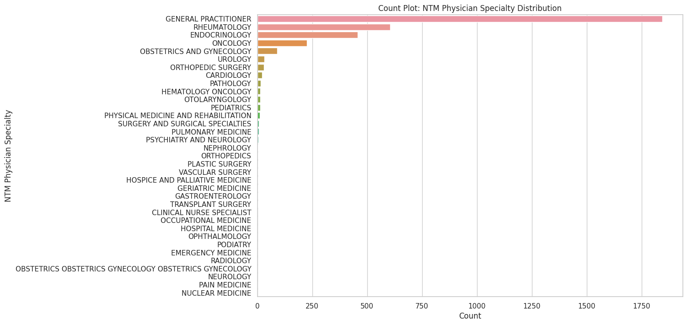

**h. Dexa Scan Frequency Analysis**

This boxplot displays the overall distribution of Dexa scan frequencies among all patients, showing a wide range but with most patients undergoing few scans, which may impact their treatment persistency.

**i. Dexa Scan Frequency by Age Bucket**

The boxplot categorizes patients by age and the frequency of Dexa scans they received. The data indicates that older patients (>75) are more likely to have frequent Dexa scans, which could be attributed to increased monitoring with advancing age.

**j. Influence of Dexa Scan Frequency on Persistency**

This boxplot illustrates the distribution of Dexa scan frequencies among patients, categorized by their drug persistency status. Notably, persistent patients tend to undergo Dexa scans more frequently, which may suggest a correlation between regular monitoring and medication adherence.

**k. Distribution of Dexa Frequency During Rx by Risk Segment**

This boxen plot compares the frequency of Dexa scans during treatment across different risk segments, suggesting that patients with a higher risk profile receive more frequent monitoring.

**l. Relationship Between Risk Factors and Drug Persistency**

The violin plot examines the relationship between the number of risk factors and drug persistency. A higher number of risk factors is associated with increased persistency, possibly due to more intensive health monitoring.

**m. Regional Distribution of Patients**

The heatmap visualizes patient distribution and drug persistency by region, offering insights into regional adherence patterns that could be vital for localized healthcare strategies.

**n. Geographic Variation in Drug Persistency**

This chart presents the geographic variation in drug persistency, with certain regions showing higher rates of non-persistence, which could inform regional healthcare policy and patient outreach efforts.

**o. Heatmap: Adherence to Therapy vs Drug Persistency**

The heatmap compares therapy adherence to drug persistency, indicating that patients who adhere to their therapy schedule are generally more persistent with their medication.

**p. Grouped Bar Chart: Impact of Comorbid Conditions on Drug Persistency**

This chart analyzes the effects of comorbid conditions on drug persistency. Certain conditions, such as chronic pain and hypertension, show a clear correlation with higher rates of persistency, likely due to the necessity of consistent treatment.

**q. Impact of Malignant Neoplasms Screening on Drug Persistency**

The bar chart demonstrates the impact of malignant neoplasms screening on drug persistency. Patients screened for neoplasms tend to be more persistent, possibly due to increased engagement with healthcare services.

**r. Glucocorticoid Usage During Therapy by Age Group**

This stacked bar chart shows glucocorticoid usage during therapy across different age groups. Older patients have higher usage, which may influence persistency due to the chronic nature of conditions treated with glucocorticoids.

**s. Distribution of Drug Persistency in Different NTM Risk Segments**

This bar chart illustrates the distribution of drug persistency within NTM risk segments. Patients in the higher risk segments show increased persistency, suggesting that risk awareness may motivate adherence to treatment.

**Final Recommendation:** Based on the EDA, it is recommended that pharmaceutical companies and healthcare providers focus on personalized patient education, regular health monitoring, and targeted interventions for patients with specific comorbid conditions and within certain demographic groups. Improving communication between general practitioners and specialists, along with addressing disparities in drug persistency across races and regions, could also significantly enhance overall medication adherence.